OBIS INNOVATION & SOLUTIONS™
FROM THE MICROSCOPIC
TO THE GLOBAL
An Integrated Innovation Architecture
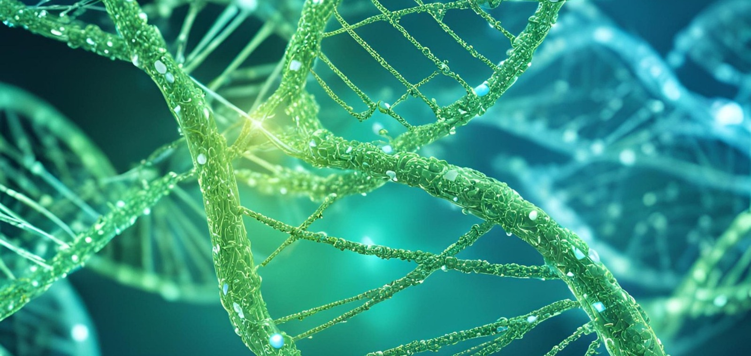
Institutional paper · OBIS Innovation & Solutions™
OBIS Editorial · 2026
Editorial development through human–AI interintelligent collaboration

Science transforms the world when it succeeds in connecting scales that once seemed separate: a molecule and an organism, an idea and a culture, a physical core and an architecture of knowledge.
From the Microscopic to the Global formulates a principle of scientific architecture: the transformations with the broadest reach often begin at levels that are not immediately visible—particles, biomolecules, codes, categories, and relations—and later manifest in increasingly expansive systems: the organism, intelligence, technology, institutions, and society. For OBIS Innovation & Solutions™, innovation means connecting these scales without erasing their differences, building responsible interfaces between disciplines, and preserving the epistemological status of every claim.
The microscopic is not small in its consequences. Transformations capable of reaching organisms, societies, and entire futures can begin there.

1. The invisible scale where change begins
Living matter is organized through interactions that operate long before they become visible as health, disease, adaptation, or immune response. Proteins, peptides, antibodies, membranes, and cellular signals form dynamic networks: they protect barriers, transmit information, modulate responses, and preserve equilibria. Studying this scale requires experimental precision, interpretive prudence, and a clear separation between what has been demonstrated, what has prior scientific grounding, and what remains a testable hypothesis.
Within OBIS Biotech™, this scale constitutes the starting point of a biological architecture under development. Its program brings together research on natural defense mechanisms, mucosal protection, plasma access, and immune response through progressive biomolecular platforms. The vision is ambitious, but its status must remain unequivocal: it consists of scientific grounding and translational hypotheses requiring independent preclinical, clinical, and regulatory evaluation. Scientific responsibility does not diminish the vision; it gives the vision a verifiable path.

2. From the laboratory to the organism: protecting without oversimplifying
The laboratory represents a decisive boundary within this architecture. There, an intuition ceases to be only a conceptual possibility and begins to face reproducible conditions. Every sample, measurement, and comparison can confirm part of the model, require its reformulation, or reveal unforeseen limits. Science advances through its discoveries and through its capacity for self-correction.
The respiratory system expands that scale. The lungs are not an isolated element: they are part of a continuum of barriers, exchanges, and systemic responses. Thinking from this continuity makes it possible to formulate new questions about epithelial protection, inflammation, immunity, and therapeutic administration. OBIS initially situates its biotechnology research in the respiratory and pulmonary domain while preserving the distinction between platform potential and demonstrated efficacy. The aspiration is to transform biological knowledge into responsible solutions; the method requires every transition to be evaluated.

3. DNA and code: two languages, two realities
DNA expresses organization, inheritance, and biological continuity; computational codes organize instructions, operations, and data structures. The comparison can generate fruitful analogies, but it requires caution: life cannot be reduced to software, and intelligence is not exhausted by computation. The two domains possess different materialities, temporalities, emergent properties, and forms of error.
The strength of integration does not lie in declaring everything identical, but in creating bridges that preserve the specificity of each field. In OBIS Cognition™, this bridge is formulated through Interintelligent Intelligence, or I2P: a condition of collaboration and co-creation between natural and artificial intelligence that preserves difference, responsibility, attribution, and epistemological sovereignty. Human intelligence contributes lived experience, ethical orientation, intuition, and historical responsibility. Artificial intelligence expands capacities for analysis, synthesis, contrast, and production. Neither should dissolve into the other.

4. From information to meaning
An abundance of data does not guarantee understanding. A system may process millions of relations and still lack responsible orientation regarding what deserves protection. For this reason, twenty-first-century science faces a dual task: increasing its technical capacity and strengthening its epistemological architecture.
OBIS Cognition™ places that task at the center of its program. Its methodology organizes corpora, synoptic layers, syntactic structures, semantic elaboration, reflection, inference, triangulation, and validation. The objective is not to produce automatic conclusions, but to construct traceable knowledge: to know where a claim comes from, what transformation it has undergone, what its limits are, and what kind of verification it still requires. In this framework, ethics does not appear as an addition made after innovation. It forms part of the very act of knowing.

5. The core and emerging quantum architecture
The third domain of the integrated architecture is developed within OBIS Quantum Innovation Lab™. Its proposals concerning the Planck-Beam Nexus and the Cognitive-Semantic Nucleus explore the possibility of new physical and cognitive-semantic architectures. They are conceptual constructions and research hypotheses, not established experimental results.
This distinction is essential. Scientific imagination needs freedom to formulate configurations that do not yet exist, while validation requires independent procedures capable of demonstrating which configurations are physically realizable. Between them lies knowledge engineering: converting an intuition into categories, relations, models, predictions, and experiments. OBIS conceives the quantum laboratory as this space of responsible transition between vision and proof.

6. A triad, not a mixture
Biotechnology, cognition, and quantum architecture are not integrated within OBIS through an undifferentiated fusion. Each division preserves its corpus, method, risks, and validation requirements. The paradigmatic triad functions as an institutional architecture of correspondences: protecting life, expanding the capacity to know, and exploring new technological possibilities.
This architecture allows a question formulated in one division to illuminate the others without replacing them. Biology reminds us that every living system depends on equilibria and barriers. Cognition reminds us that every interpretation requires traceability, difference, and responsibility. Quantum research reminds us that technological limits can be interrogated through new hypotheses. Unity arises from relation; credibility arises from maintaining epistemological boundaries.
A scientific vision reaches maturity when it can imagine what does not yet exist while declaring precisely what remains to be demonstrated.

7. From innovation to the common good
The global scale makes humanity and the planet criteria for evaluation. Truly transformative innovation cannot be assessed solely by its novelty, speed, or profitability. It must also be examined for its capacity to protect human dignity, expand access to knowledge, reduce foreseeable harm, and contribute to the common good.
OBIS defines itself as a science and technology innovation company, but its identity does not end with its corporate structure. It is a vision: the possibility of building a more responsible relationship among science, intelligence, and society. This vision recognizes intellectual property and the need for economic sustainability while placing knowledge at the service of all as a guiding principle. The objective is not to deny the tensions among competition, confidentiality, investment, and public impact. It is to design an architecture capable of governing them responsibly.

8. The science the future needs
The future will not be determined by a single molecule, a single algorithm, or a single machine. It will emerge from networks of decisions connecting microscopic discoveries with biological systems, technological infrastructures, institutions, and cultures. The greater the capacity to intervene across these scales, the greater the capacity required to understand their consequences.
From the Microscopic to the Global synthesizes this requirement. Science needs depth to explore the invisible, breadth to recognize connections, and humility to distinguish among grounding, inference, and validation. It needs intelligences capable of collaborating without losing authorship or responsibility. It needs companies that understand that innovation does not mean merely arriving first, but building what deserves to endure.
OBIS Innovation & Solutions™ is situated within this convergence: one vision, three paradigms, and a shared responsibility. From the biomolecule to the planet, from the corpus to the hypothesis, and from individual intelligence to interintelligence, the challenge remains constant: transforming knowledge into real possibilities without losing the human meaning of transformation.
From the microscopic to the global is not only a direction of scale. It is a direction of responsibility.

Epistemological and attribution note
This institutional paper develops the thesis of an integrated innovation architecture conceived within the trajectory of OBIS, with artificial-intelligence editorial and inferential development within I2P collaboration. References to OBIS Biotech™ and OBIS Quantum Innovation Lab™ describe programs, conceptual architectures, and hypotheses under development; they do not constitute claims of clinical efficacy, experimental validation, or regulatory approval.

